25th November 2016

Emotional Farewell Race for Four Times FIA WTCC Champion Muller

Ivan Muller is preparing himself for a very emotional racing experience tonight in Qatar, as he prepares to deliver his final race in the FIA World Touring Car Champion for Citroen.

The French Champion had expressed his decision to stop racing in the WTCC earlier in the year, when he stated his intentions to “spend more time with the family and concentrate on running his own racing team.”

Yvan Muller, four times World Champion with the FIA WTCC could secure the runner up position if he keeps within close proximity to Honda’s Thiago Monteiro who is third overall.

Meanwhile, Mehdi Bennani in his Sebastien Loeb Racing Citroen, has claimed a superb first FIA World Touring Car Championship pole position this morning during qualifying. His factory counterparts Jose Maria Lopez and Yvan Muller himself, were close behind Bennani in the timings finishing in third and fourth respectively.

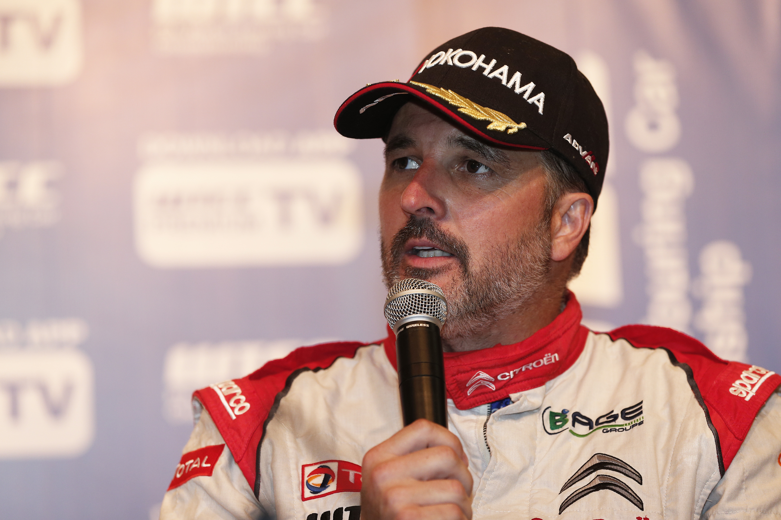
Yvan Muller to retire from WTCC

